CLOUD SERVICES FOR AI
ASSIGNMENT – 3
TOPIC: IAM USER AND USER GROUP CREATION
STEP -1
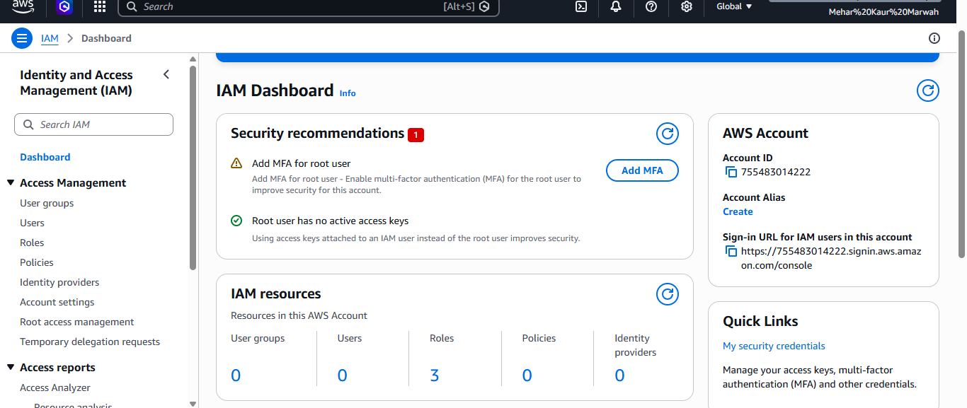We Login to AWS as Root user and go to IAM Dashboard through search box .
STEP-2
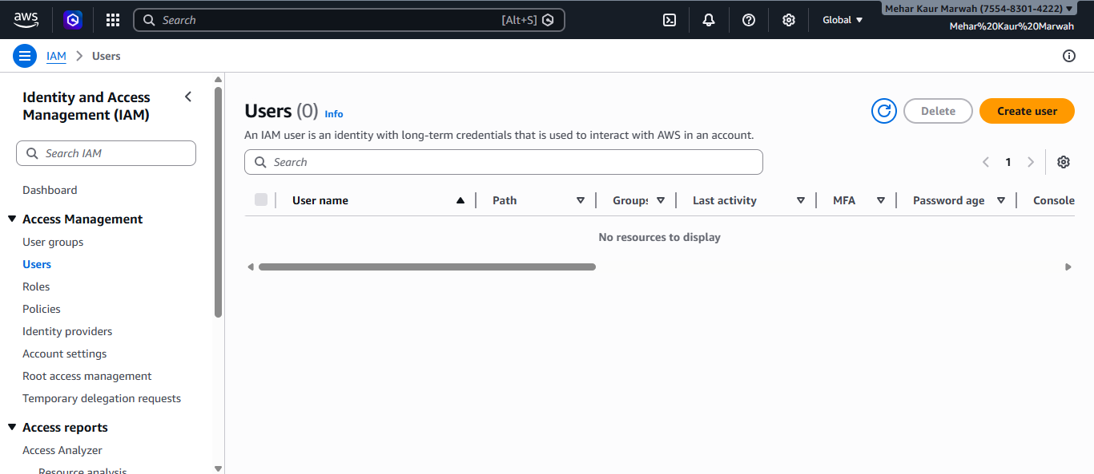
After going to IAM Dashboard , now we go to Users in the top left column .

STEP- 3
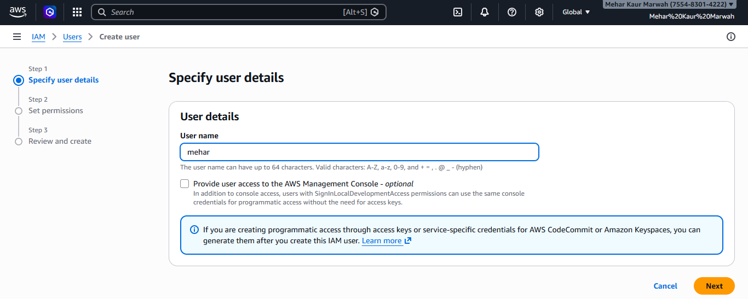
After going to Create user box on the top right side, we land on the page called User details. Here we give A name to the user. In the image We are creating a first username mehar.
STEP – 4
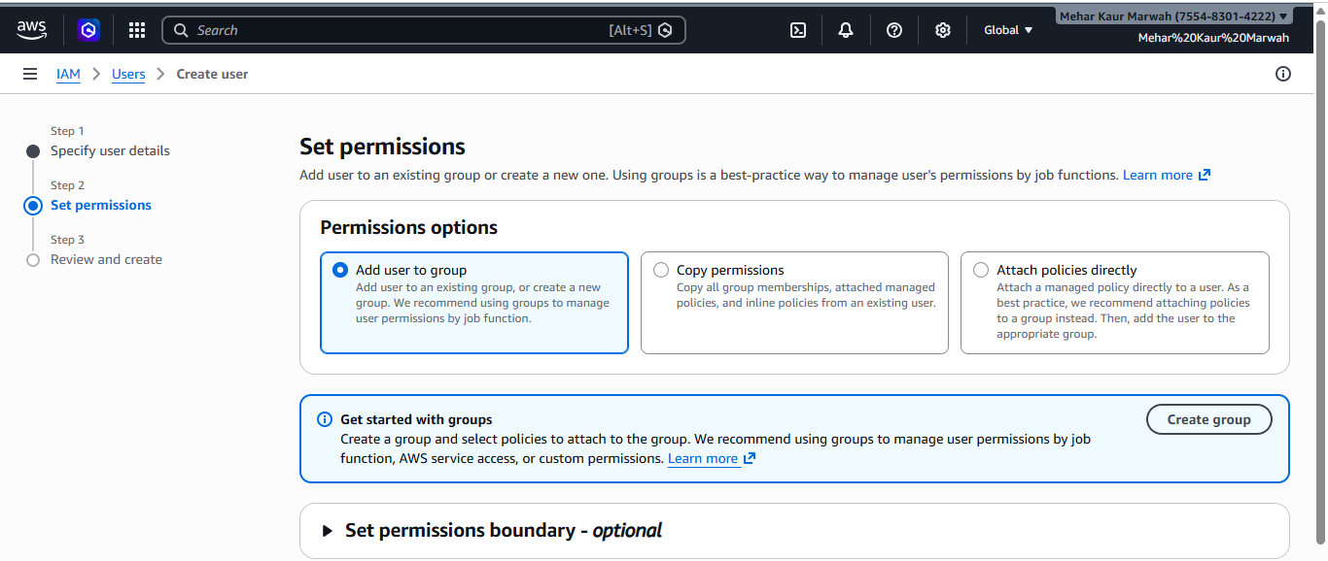
When we scroll down, we get to the Set permissions, here we choose Add user to group option as we are going to add the users in the group we will create.We also get the option of adding policies in the user that are the permissions the user has.
STEP-5
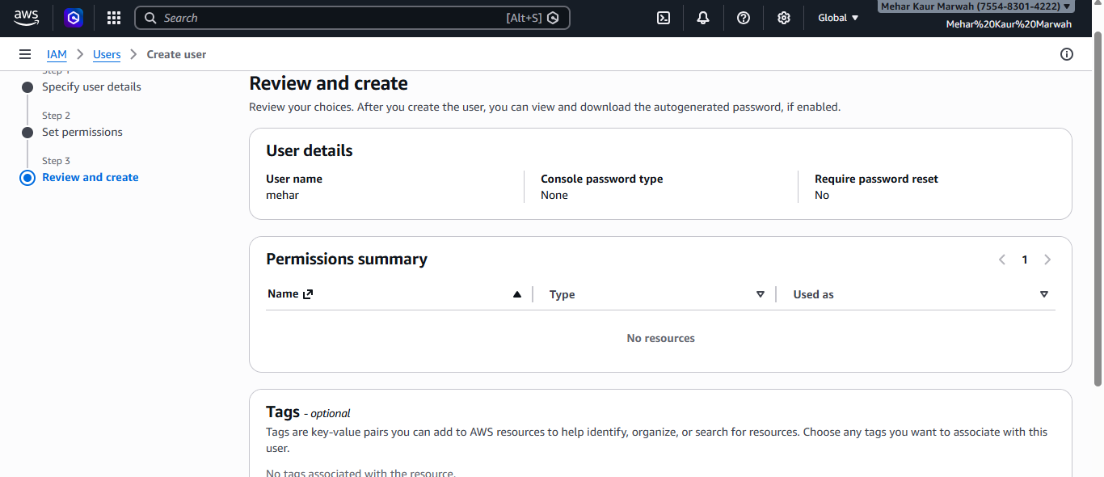
Then we go to Review and create and recheck all the details and then go to the option create user ..
STEP-6
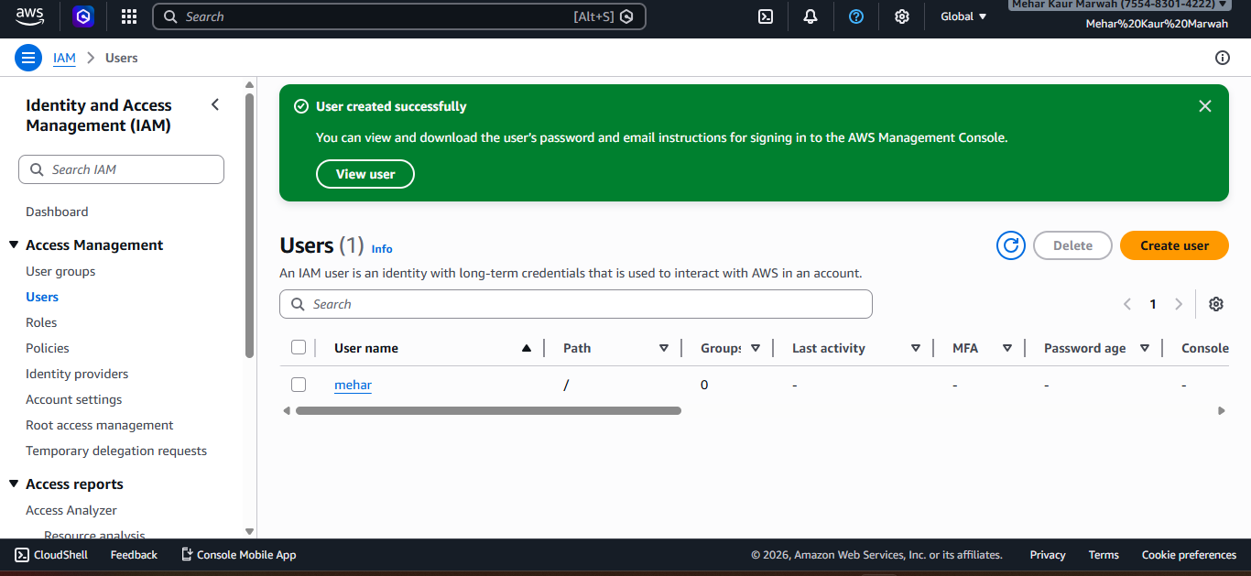
Now Are first user is ready

STEP-7
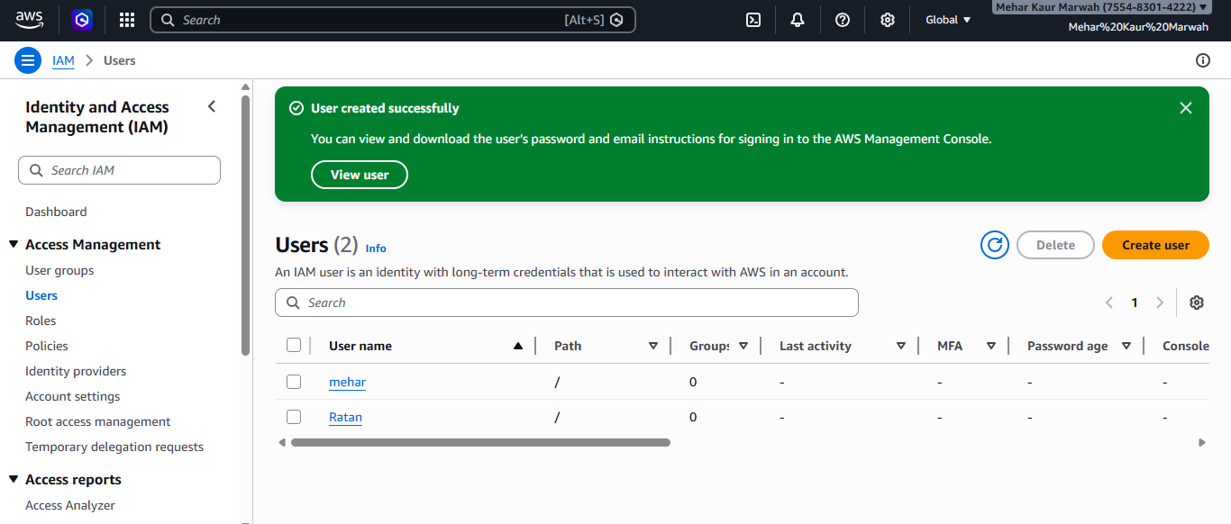
Similarly we have created a user 2 (Ratan) , following the same steps we did in creation of user 1 (Mehar).
STEP-8
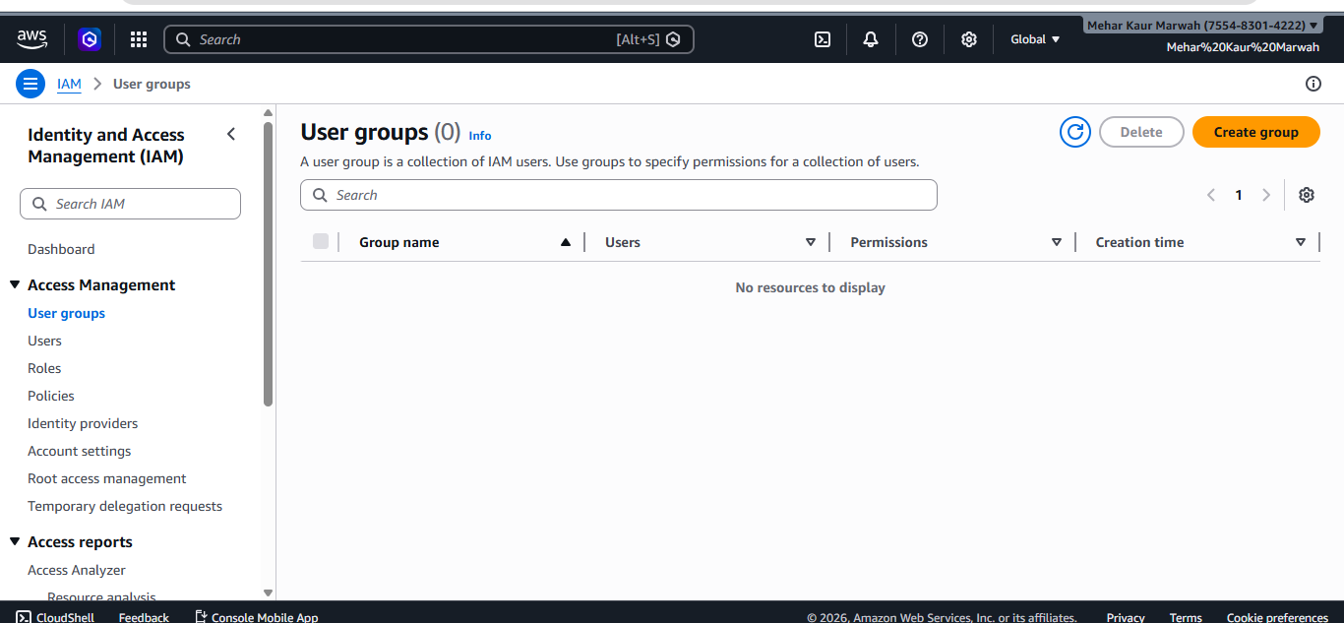
Now we went to User groups under Access Management in the top left corner. After entering the window of User group we go to Create group on right hand side .

STEP-9
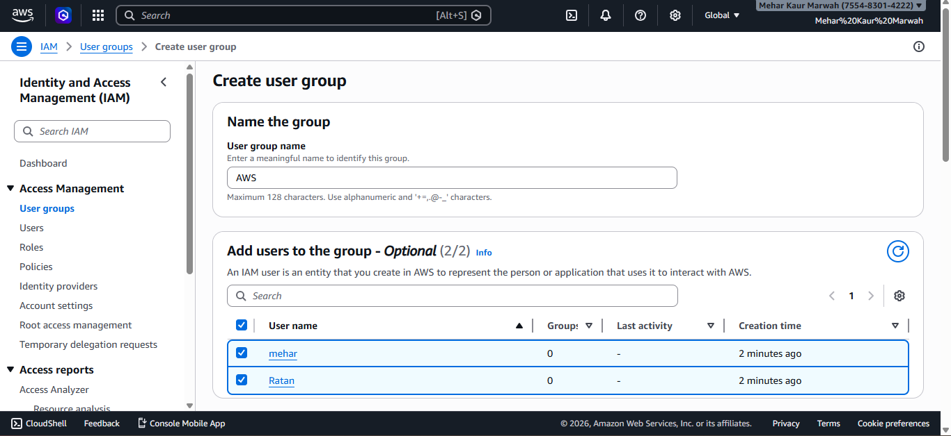
Now we will reach to the Create User window . Here we fill up the baic details of the User group. First is Name the group , here I gave the name a AWS. And then I selected the users that we created so we can add users to the group .
STEP-10
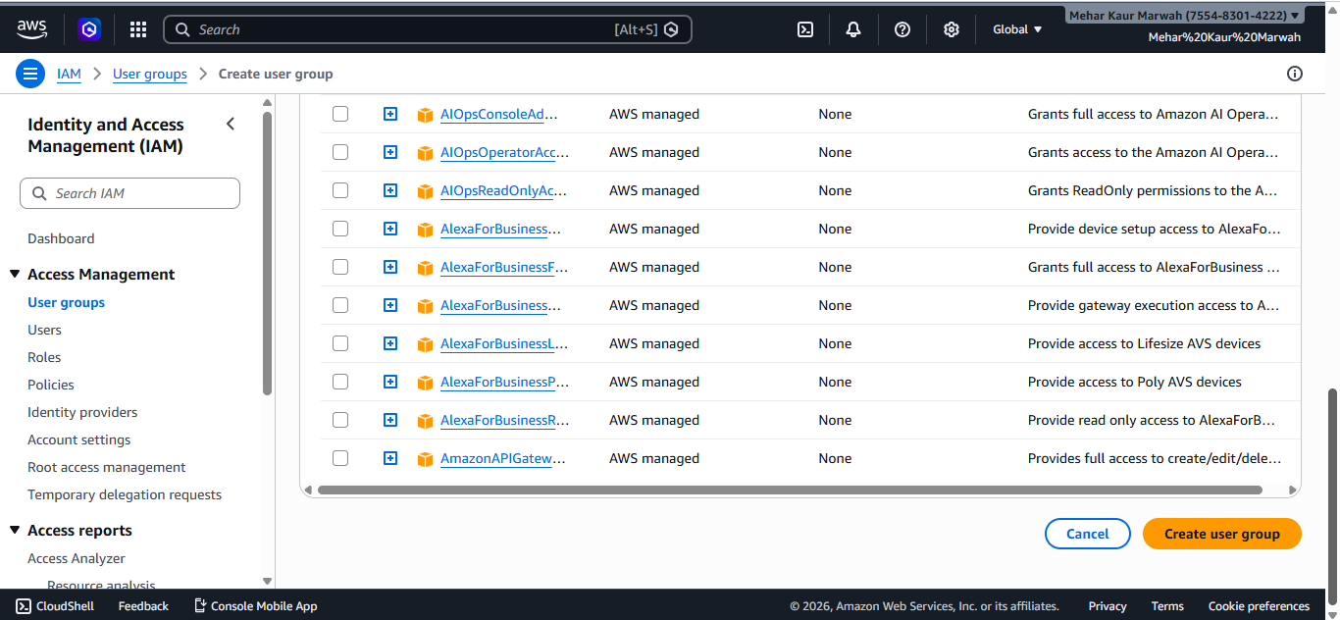
Scrolling down , we see the polices or in simple terms the permission that are Users have. I kept the selection as it is by default and then we click on Create user group in the yellow box on bottom right corner .

STEP-11

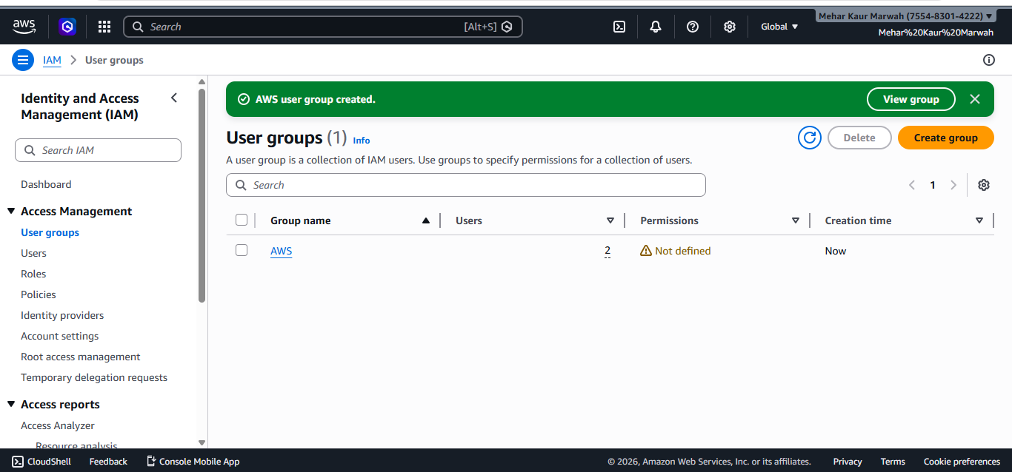
Are group has now officially been created with the users having permissions with them
STEP-12
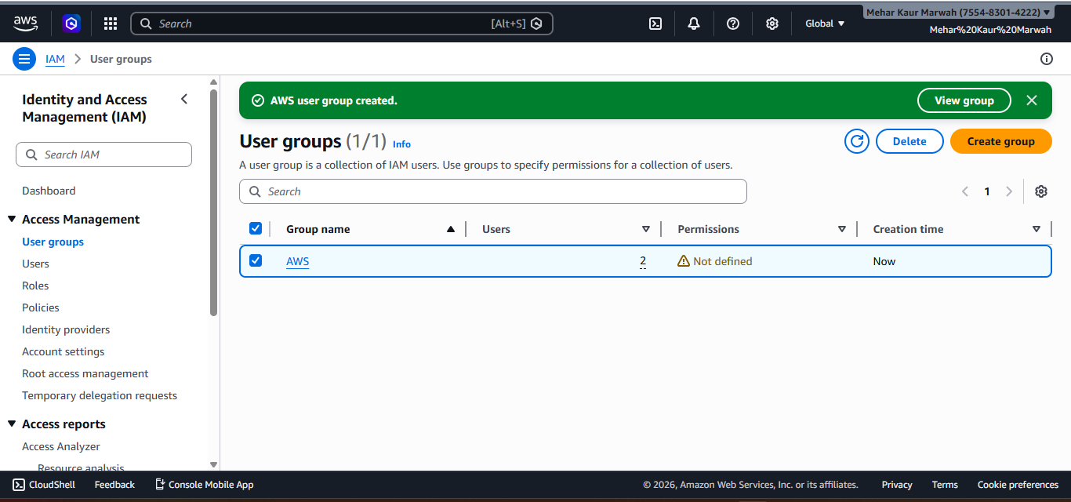
Now we elect the group by clicking on the mini box on left side of the group name .

STEP-13
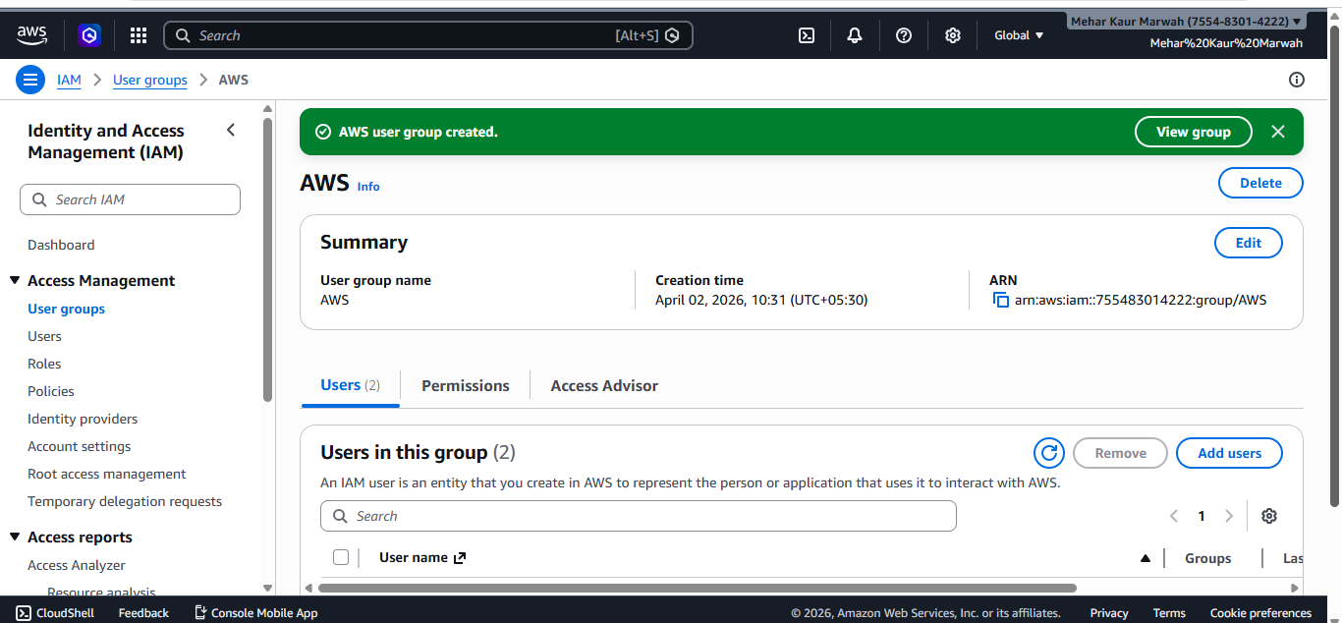
Now we can see our group created and now work on it .

